**Assignment 7**

**1.Insert Trigger**

use Company;

GO

Create Trigger tr_Employees_ForInsert

on Employees

For Insert

As

BEGIN

Declare @Id int

Select @Id= Emp_Id from Inserted

insert into Employee_Test_Audit

values(@Id,('New Employee with id ='+cast(@Id as nchar(10))+'is added at'+cast(GETDATE() as nvarchar)))

END

Go

insert into Employees values(122,'Mayank','Singh','Trichy','2019-02-01',75000,3,1);

select * from Employees;

Select * from Employee_Test_Audit;

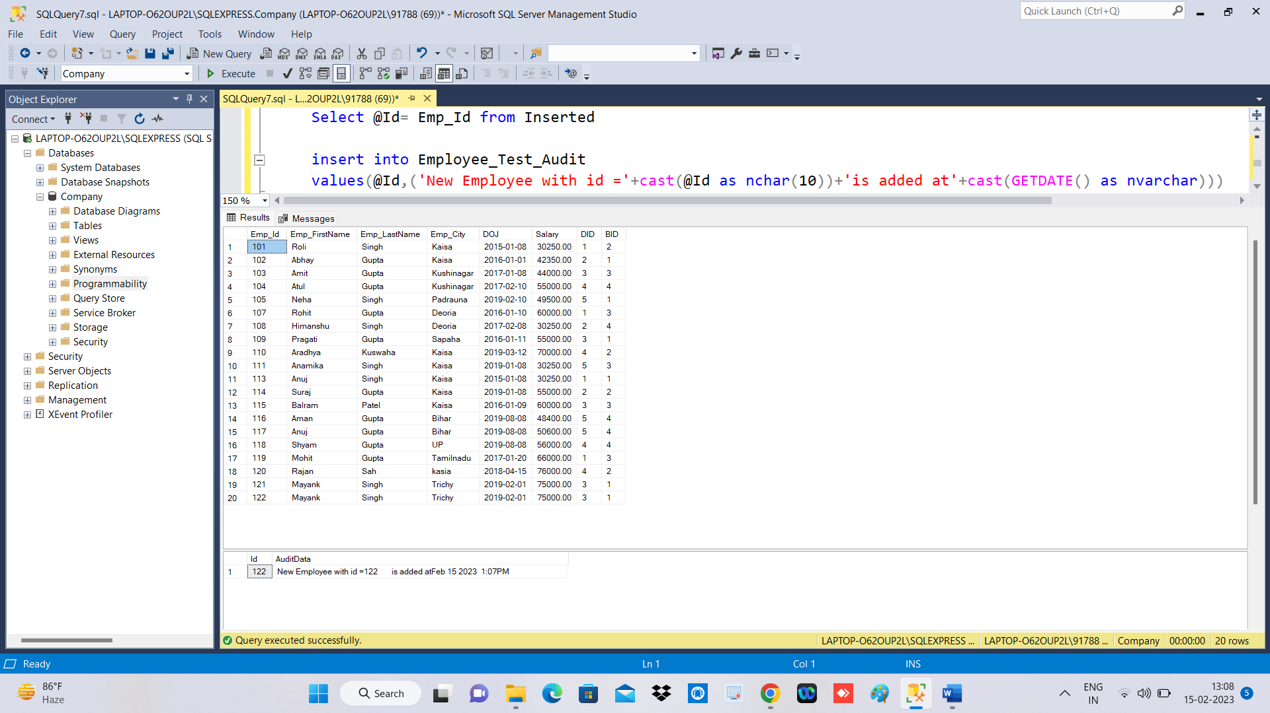

**2.Delete Trigger**

Go

Create Trigger tr_Employees_ForDelete

on Employees

For Delete

As

BEGIN

Declare @Id int

Select @Id= Emp_Id from deleted

insert into Employee_Test_Audit

values(@Id,('AnE Existing Employee with id ='+cast(@Id as nchar(10))+'is deleted at'

+cast(GETDATE() as nvarchar)))

END

Go

**Table Before Deletion**

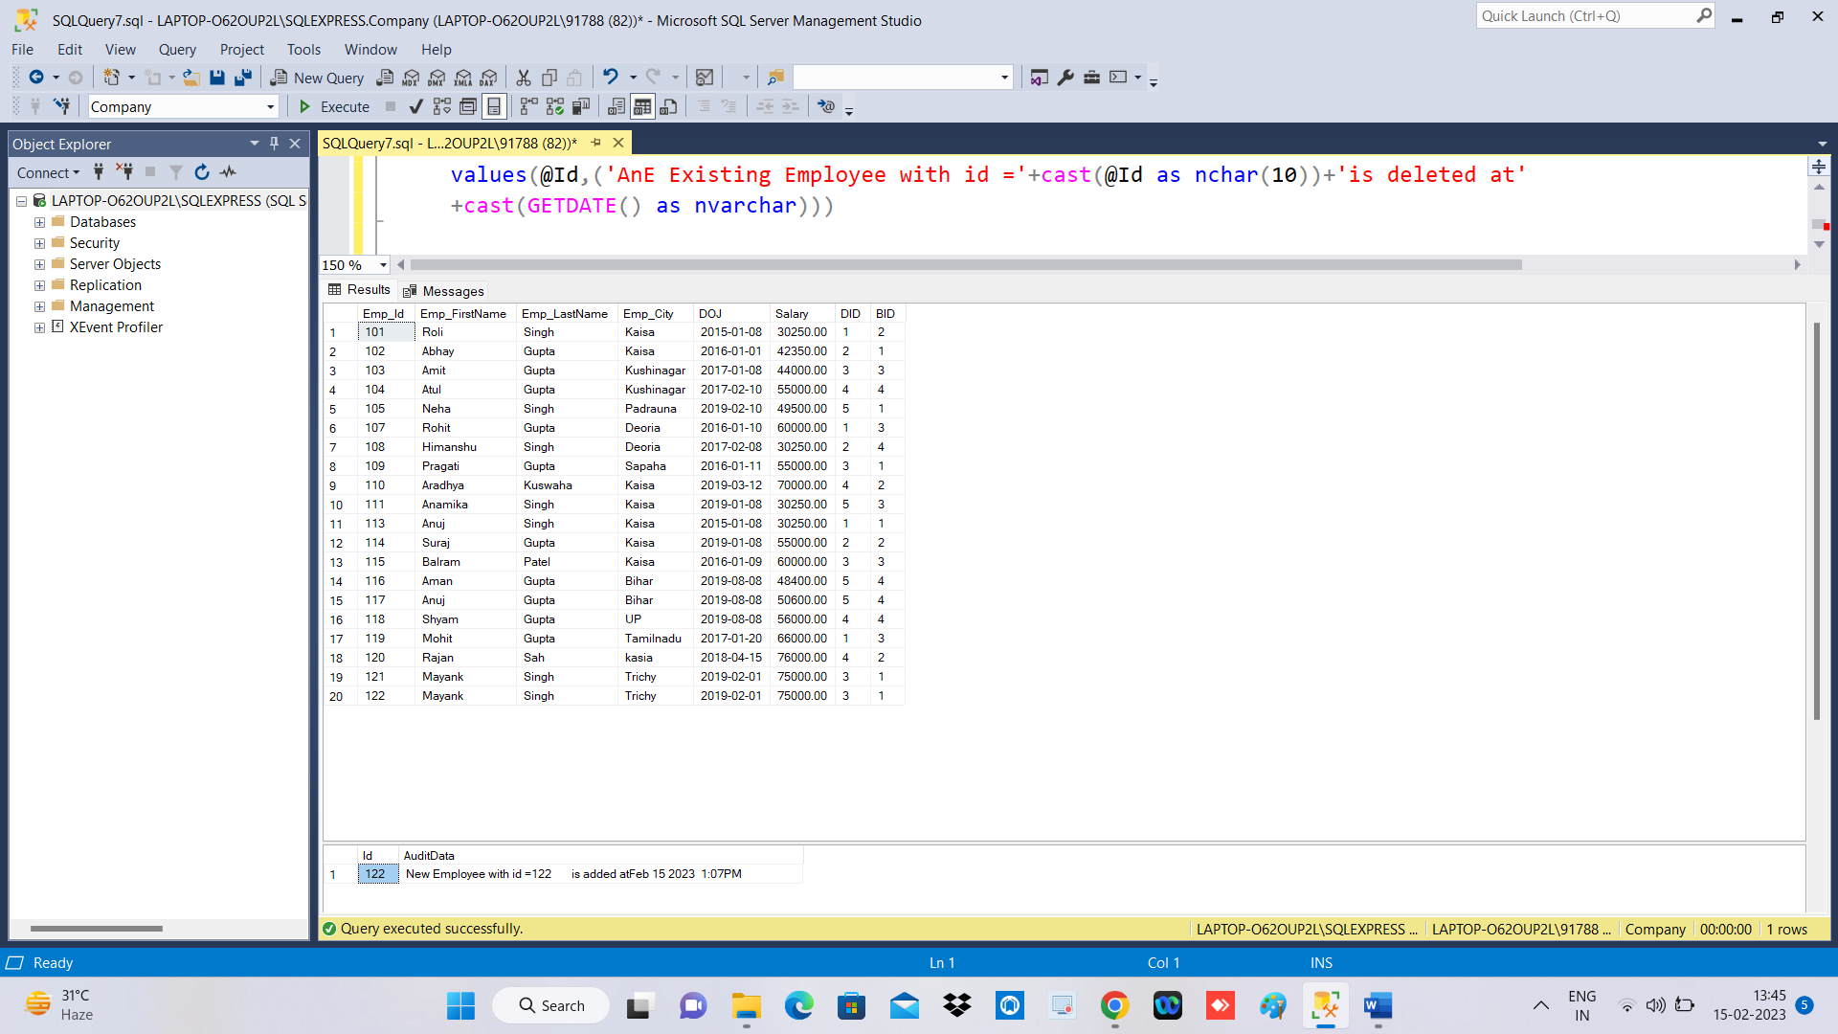

**Table After Deletion**

Delete from Employees where Emp_Id=122;

select * from Employees;

Select * from Employee_Test_Audit;

